**Matrix Elements and Matrix Operations using MATLAB**

**Objective:**

To provide hands-on practice in MATLAB, covering matrix creation and matrix operations.

1. Create the following matrix M (4 X 4).

M = [4 -2 -4 7, 1 5 -3 2, 6 -8 -5 -6, -7 3 0 1]

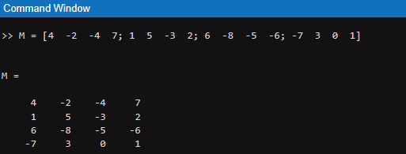

1. Access the following elements of matrix M. M(3,1) and M(2,3)

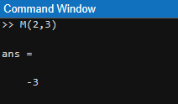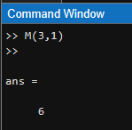

1. Access the following elements of matrix M using a single number. (-8, -3)

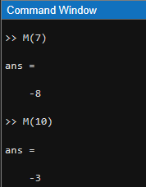

1. Using the single indexing extract, the elements belong to these indexes. (1 6 11 16)

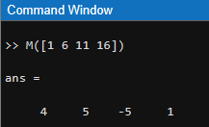

1. Lists all values in row 1 which are between columns 1 and 3 inclusive.

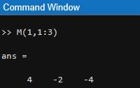

1. 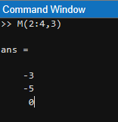Lists all the values in column 3 which are between rows 2 to 4 inclusive.
2. 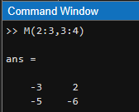Lists the 2 by 2 block of values which lie between rows 2 to 3 and columns 3 to 4.
3. Access the entire first column in matrix M

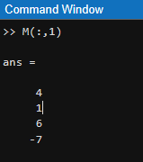

1. Access the entire third row in matrix M.

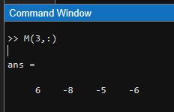

**Matrix Operations**

1. Create the following matrix N (4X4).

N = [2 4 -7 -4, 0 0 3 -2, 0 -8 -0 -3, 0 -6 7 1]

M = [4 -2 -4 7, 1 5 -3 2, 6 -8 -5 -6, -7 3 0 1]

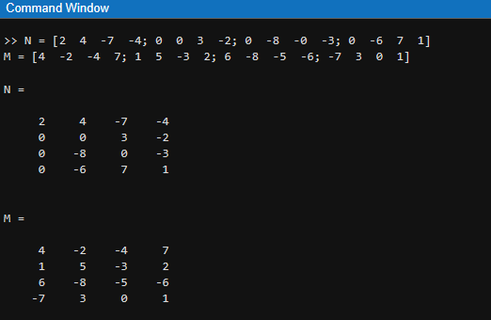

1. Add the matrices N and M.

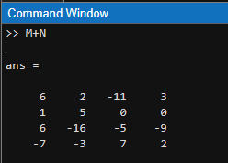

1. Subtract the matrix M from matrix N.

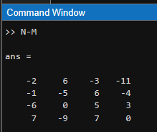

1. Multiply both matrices N and M.

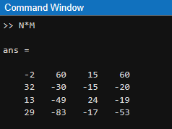

1. Create following matrix C (3X2) and matrix D (2X3).

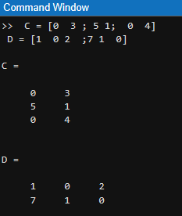C = [0 3 , 5 1, 0 4] and D = [1 0 2 ,7 1 0]

1. 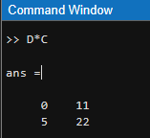Find the answers for C * D and D * C.

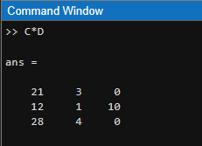

1. Find $N^{2}$

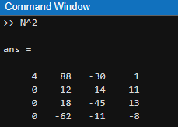

1. Find 3N – 2M

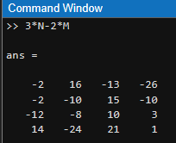

1. Find ${(N}^{2}$- $M^{2})$

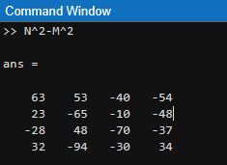

1. Find the inverse matrices of M and D.

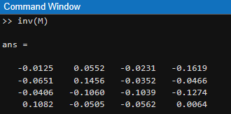

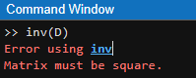

1. Find $N^{T}$ and $C^{T}$

You can use both ways

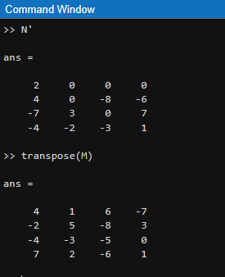

1. Return M with the order of element flipped upside down along the first dimension.

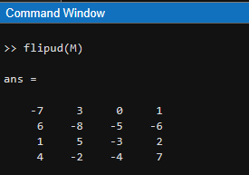

1. Find ${(MN)}^{T}$

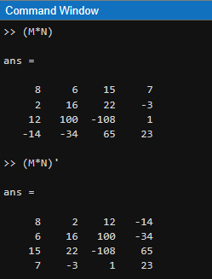

1. Return M with the order of element fliplr flip left to right along the first dimension.

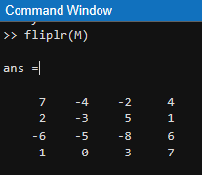

1. Rotate matrix M in 90 degrees.

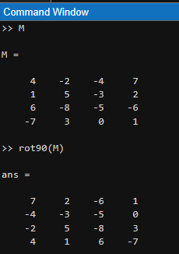

1. Reshape the matrix N in to (8 x 2)

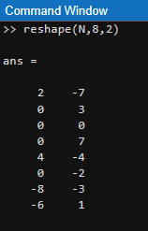

1. Produce the matrix whose elements are the products of the corresponding elements of M and N.

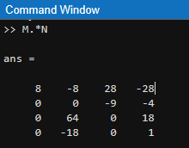

1. Produces a matrix each element of which is a square of the corresponding elements of M.

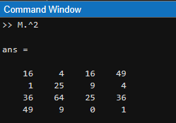

1. Produce a matrix of reciprocals by writing 1./M

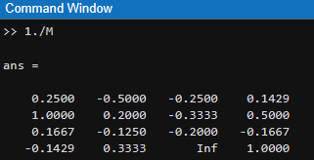

1. Construct random integer matrices by multiplying the results of **rand** by 3. Then use the floor function to take the integer part of the result.

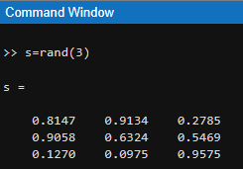

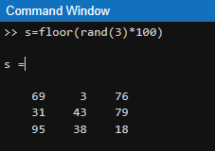

1. Construct random integer matrices by multiplying the results of **randn** by 3 and 5. Then use the floor function to take the integer part of the result.

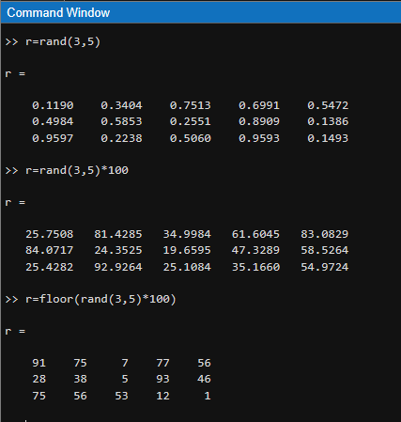

**Exercise 03 (For You do your own)**

1. Create the matrix X = [ 5 0 4 , 0 1 0, 1 2 9]
2. Find the inverse of X.
3. Find the transpose of X.
4. Use the command flipud and fliplr.
5. Rotate matrix X in 90 degrees.
6. Create the matrix P = [ 1 0 9 2, 3 ­ 0 12 4, -5 7 -7 6]
7. Reshape the matrix (2 * 6) and (4 * 3)